**VPROFILE PROJECT SETUP**

# Prerequisite

1. Oracle VM Virtualbox
2. Vagrant
3. Vagrant plugins
   1. vagrant plugin install vagrant-hostmanager
   2. vagrant plugin install vagrant-vbguest
4. Git bash or equivalent editor

# VM SETUP

1. Clone source code.
2. Cd into the repository.
3. Switch to local-setup branch.
4. cd into vagrant/Manual_provisioning.

Bring up vm’s

*$ vagrant up*

NOTE: Bringing up all the vm’s may take a long time based on various factors. If vm setup stops in the middle run “vagrant up” command again.

INFO: All the vm’s hostname and /etc/hosts file entries will be automatically updated.

# PROVISIONING

## Services

1. Nginx:

Web Service

1. Tomcat

Application Server

1. RabbitMQ

Broker/Queuing Agent

1. Memcache

DB Caching

1. ElasticSearch

Indexing/Search service

1. MySQL

SQL Database

Setup should be done in below mentioned order

1. MySQL (Database SVC)
2. Memcache (DB Caching SVC)
3. RabbitMQ (Broker/Queue SVC)
4. Tomcat (Application SVC)
5. Nginx (Web SVC)

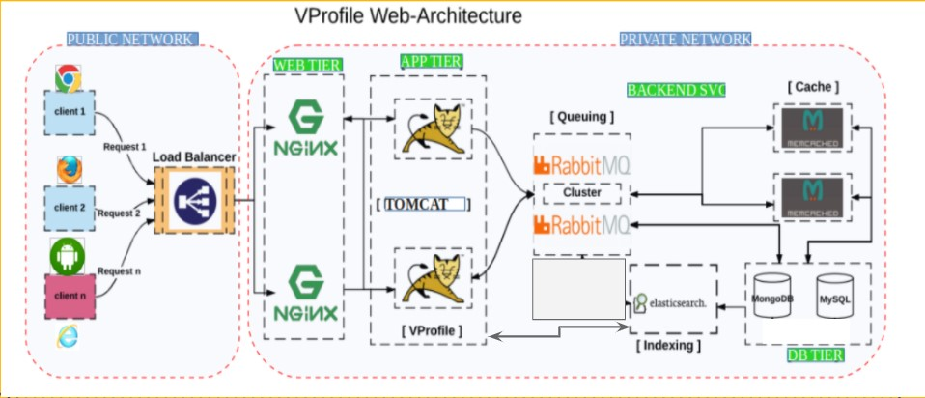

# MYSQL Setup

Login to the db vm

*$ vagrant ssh db01*

Verify Hosts entry, if entries missing update it with IP and hostnames

*# cat /etc/hosts*

Update OS with latest patches

*# yum update -y*

Set DB password Variable

$ sudo -i ------------------------to switch to root user

*# DATABASE_PASS='admin123'*

# echo $*DATABASE_PASS*

*#* vim /etc/profile

*DATABASE_PASS='admin123'*

*:wq*

# source /etc/profile ------------------------to make this variable permanent

Set Repository

*# yum install epel-release -y*

Install Maria DB Package

*# yum install git mariadb-server -y*

## Starting & enabling mariadb-server

*# systemctl start mariadb*

*# systemctl enable mariadb*

RUN mysql secure installation script.

*# mysql_secure_installation*

***NOTE****: Set db root password as same as you set in the variable above (DATABASE_PASS='admin123')*

Set root password? [Y/n] Y New password:

Re-enter new password:

Password updated successfully!

Reloading privilege tables.. ... Success!

By default, a MariaDB installation has an anonymous user, allowing anyone to log into MariaDB without having to have a user account created for them. This is intended only for testing, and to make the installation go a bit smoother. You should remove them before moving into a production environment.

Remove anonymous users? [Y/n] Y

... Success!

Normally, root should only be allowed to connect from 'localhost'. This ensures that someone cannot guess at the root password from the network.

Disallow root login remotely? [Y/n] n ... skipping.

By default, MariaDB comes with a database named 'test' that anyone can access. This is also intended only for testing, and should be removed before moving into a production environment.

Remove test database and access to it? [Y/n] Y - Dropping test database...

... Success!

- Removing privileges on test database... ... Success!

Reloading the privilege tables will ensure that all changes made so far will take effect immediately.

Reload privilege tables now? [Y/n] Y ... Success!

To test the login

# mysql -u root -p

Enter pw. If login successful enter ‘exit’ to come out

## Download Source code

*# git clone -b local-setup https://github.com/devopshydclub/vprofile-project.git*

# cd *vprofile-project*

Set DB name and users.

*# mysql -u root -p"$DATABASE_PASS" -e "create database accounts"*

*# mysql -u root -p"$DATABASE_PASS" -e "grant all privileges on accounts.* TO*

*'admin'@'app01' identified by 'admin123' "*

*# mysql -u root -p"$DATABASE_PASS" accounts < src/main/resources/db_backup.sql*

*# mysql -u root -p"$DATABASE_PASS" -e "FLUSH PRIVILEGES"*

Restart mariadb-server

*# systemctl restart mariadb*

## Starting the firewall and allowing the mariadb to access from port no. 3306

*# systemctl start firewalld*

*# systemctl enable firewalld*

*# firewall-cmd --get-active-zones*

*# firewall-cmd --zone=public --add-port=3306/tcp --permanent*

*# firewall-cmd --reload*

*# systemctl restart mariadb*

# MEMCACHE SETUP

Install, start & enable memcache on port 11211

*#yum install epel-release -y*

*#yum install memcached -y*

*#systemctl start memcached*

*#systemctl enable memcached*

*#systemctl status memcached*

*#memcached -p 11211 -U 11111 -u memcached -d*

## Starting the firewall and allowing the port 11211 to access memcache

*# systemctl enable firewalld*

*# systemctl start firewalld*

*# systemctl status firewalld*

*# firewall-cmd --add-port=11211/tcp --permanent*

*# firewall-cmd --reload*

*# memcached -p 11211 -U 11111 -u memcache -d*

# RABBITMQ SETUP

Login to the RabbitMQ vm *$ vagrant ssh rmq01*

Verify Hosts entry, if entries missing update the it with IP and hostnames *# cat /etc/hosts*

Update OS with latest patches

*# yum update -y*

Set EPEL Repository

*# yum install epel-release -y*

## Install Dependencies

*# yum install socat -y*

*# yum install wget -y*

## Create Repo file for Erlang package

*# wget http://packages.erlang-solutions.com/erlang-solutions-2.0-1.noarch.rpm*

*# sudo rpm -Uvh erlang-solutions-2.0-1.noarch.rpm*

## Install Erlang # yum install erlang -y

Run below mentioned command to setup rabbitmq-server repo file.

NOTE: Make sure to copy below command in a notepad remove newline character and then paste it in the terminal

## # curl -s https://packagecloud.io/install/repositories/rabbitmq/rabbitmq-server/script.rpm.sh | sudo bash

Install Rabbitmq Server

# yum install rabbitmq-server -y

## Start & Enable RabbitMQ

# systemctl start rabbitmq-server

# systemctl enable rabbitmq-server

# systemctl status rabbitmq-server

Config Changes

*# echo "[{rabbit, [{loopback_users, []}]}]." > /etc/rabbitmq/rabbitmq.config*

## Add user test in rabbitmq

*# rabbitmqctl add_user test test*

*Set admin privileges to rabbit user*

*# rabbitmqctl set_user_tags test administrator*

Restart RabbitMQ service

*# systemctl restart rabbitmq-server*

## Enabling the firewall and allowing port 25672 to access the rabbitmq permanently

*# systemctl start firewalld*

*# systemctl enable firewalld*

*# firewall-cmd --get-active-zones*

*# firewall-cmd --zone=public --add-port=25672/tcp --permanent*

*# firewall-cmd --reload*

# TOMCAT SETUP

Login to the tomcat vm

*$ vagrant ssh app01*

Verify Hosts entry, if entries missing update the it with IP and hostnames *# cat /etc/hosts*

Update OS with latest patches

*# yum update -y*

Set Repository

*# yum install epel-release -y*

## Install Dependencies

# yum install java-1.8.0-openjdk -y

# yum install git maven wget -y

Change dir to /tmp *# cd /tmp/*

## Download & Tomcat Package

*# wget* [*https://archive.apache.org/dist/tomcat/tomcat-8/v8.5.37/bin/apache-tomcat-8.5.37.tar.gz*](https://archive.apache.org/dist/tomcat/tomcat-8/v8.5.37/bin/apache-tomcat-8.5.37.tar.gz) *-O tomcatbin.tar.gz*

*Optional Step, Below variables are used in “Copy data to tomcat home dir” step. You can use the tomcat directory name also in the source.*

*# EXTOUT=`tar xzvf tomcatbin.tar.gz`*

*# TOMDIR=`echo $EXTOUT | cut -d '/' -f1`*

Add tomcat user

*# useradd --home-dir /usr/local/tomcat8 --shell /sbin/nologin tomcat*

## Copy data to tomcat home dir

*# rsync -avzh /tmp/$TOMDIR/ /usr/local/tomcat8/*

Make tomcat user owner of tomcat home dir *# chown -R tomcat.tomcat /usr/local/tomcat8*

## Setup systemd for tomcat

Update file with following content. *vi /etc/systemd/system/tomcat.service*

[Unit]

Description=Tomcat

After=network.target

[Service]

User=tomcat

WorkingDirectory=/usr/local/tomcat8

Environment=JRE_HOME=/usr/lib/jvm/jre

Environment=JAVA_HOME=/usr/lib/jvm/jre

Environment=CATALINA_HOME=/usr/local/tomcat8

Environment=CATALINE_BASE=/usr/local/tomcat8

ExecStart=/usr/local/tomcat8/bin/catalina.sh run

ExecStop=/usr/local/tomcat8/bin/shutdown.sh

SyslogIdentifier=tomcat-%i

[Install]

WantedBy=multi-user.target

*# systemctl daemon-reload*

*# systemctl start tomcat*

*# systemctl enable tomcat*

## Enabling the firewall and allowing port 8080 to access the tomcat

*# systemctl start firewalld*

*# systemctl enable firewalld*

*# firewall-cmd --get-active-zones*

*# firewall-cmd --zone=public --add-port=8080/tcp --permanent*

*# firewall-cmd --reload*

# CODE BUILD & DEPLOY (app01)

Download Source code

*# git clone -b local-setup https://github.com/devopshydclub/vprofile-project.git*

## Update configuration

*# cd vprofile-project*

*# vim src/main/resources/application.properties*

*# Update file with backend server details*

## Build code

*Run below command inside the repository (vprofile-project)*

*# mvn install*

## Deploy artifact

*# systemctl stop tomcat*

*# sleep 120*

*# rm -rf /usr/local/tomcat8/webapps/ROOT\**

*# cp target/vprofile-v2.war /usr/local/tomcat8/webapps/ROOT.war*

*# systemctl start tomcat*

*# sleep 300*

*# chown tomcat.tomcat usr/local/tomcat8/webapps -R*

*# systemctl restart tomcat*

# NGINX SETUP

Login to the Nginx vm

*$ vagrant ssh web01*

Verify Hosts entry, if entries missing update the it with IP and hostnames *# cat /etc/hosts*

## Update OS with latest patches

*# apt update*

*# apt upgrade*

Install nginx

*# apt install nginx -y*

## Create Nginx conf file with below content # vi /etc/nginx/sites-available/vproapp

*upstream vproapp {*

*server app01:8080;*

*}*

*server {*

*listen 80;*

*location / {*

*proxy_pass http://vproapp;*

*}*

*}*

Remove default nginx conf

*# rm -rf /etc/nginx/sites-enabled/default*

Create link to activate website

*# ln -s /etc/nginx/sites-available/vproapp /etc/nginx/sites-enabled/vproapp*

## Restart Nginx

*# systemctl restart nginx*